**Percentile**

A **percentile** is a value below which a given percentage of observations fall. It helps in understanding the relative standing of a data point within a dataset.

### **Formula for Percentile Rank**

To find the percentile rank of a value X:

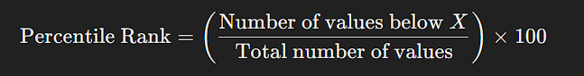

### **Example**

Consider this dataset (sorted):  
 **10, 20, 30, 40, 50, 60, 70, 80, 90, 100**

* **Find the 70th percentile:**
  + **70% of 10 values** = **7th value** (count from the lowest)
  + The **7th value is 70**, so the **70th percentile is 70**.

### **Common Percentiles & Their Meaning**

| **Percentile** | **Meaning** |
| --- | --- |
| **25th percentile (Q1 - First Quartile)** | 25% of values are below this point |
| **50th percentile (Q2 - Median)** | 50% of values are below this point |
| **75th percentile (Q3 - Third Quartile)** | 75% of values are below this point |
| **90th percentile** | 90% of values are below this point (used in performance analysis) |

### **Real-life Applications of Percentiles**

✅ **Exams & Scores**: "You scored in the 90th percentile" means you did better than 90% of students.  
 ✅ **Salary Analysis**: A salary at the 75th percentile is higher than 75% of other salaries.  
 ✅ **Health & Growth Charts**: A baby’s weight at the 60th percentile means it’s heavier than 60% of other babies.

Would you like a Python example to calculate percentiles? 😊